Hackathon assignment

1

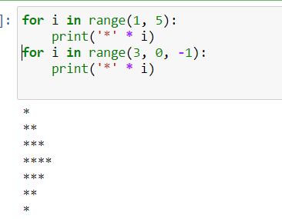

2. import math

even_nums = []

odd_nums = []

for i in range(5):

num = int(input("Enter an even number: "))

if num % 2 == 0:

even_nums.append(num)

else:

print("Invalid input. Enter an even number.")

i -= 1

for i in range(5):

num = int(input("Enter an odd number: "))

if num % 2 != 0:

odd_nums.append(num)

else:

print("Invalid input. Enter an odd number.")

i -= 1

even_sum = sum(even_nums)

odd_product = 1

for num in odd_nums:

odd_product *= num

abs_diff = abs(even_sum - odd_product)

is_prime = True

for i in range(2, int(math.sqrt(abs_diff)) + 1):

if abs_diff % i == 0:

is_prime = False

break

print("Sum of even numbers:", even_sum)

print("Product of odd numbers:", odd_product)

print("Absolute difference of sum and product:", abs_diff)

if is_prime:

print("Absolute difference is a prime number.")

else:

print("Absolute difference is not a prime number.")

3.

class Item:

def __init__(self, name, price, quantity):

self.name = name

self.price = price

self.quantity = quantity

def getName(self):

return self.name

def getPrice(self):

return self.price

def getQuantity(self):

return self.quantity

def getValue(self):

return self.price * self.quantity

4. # input number of rows

num_rows = int(input("Enter the number of rows: "))

# Generate the series of 9's

series = ""

for i in range(num_rows):

series += "9" * (i+1) + "\n"

# Print the series

print(series)

5. # input the number

num = int(input("Enter a number: "))

# Check if the number is prime

if num > 1:

for i in range(2, int(num/2)+1):

if num % i == 0:

print(num, "is not a prime number")

break

else:

print(num, "is a prime number")

else:

print(num, "is not a prime number")